BS (SE) FINAL PROJECT
Phase 2

Smart IoT-Based Parking System Using Arduino


Project Advisor
Dr. Muhammad Ahmad Niaz

Presented by:

Mudassir Nadeem
F21NSEEN1M01096

Muhammad Ahmad
F21NSEEN1M01101

Muhammad Ahsaan
F21NSEEN1M01088

Faculty of Computing
Department of Software Engineering

The Islamia University of Bahawalpur
Bahawalnagar Campus

Software Requirements Specification

Date | Version | Description
Current date | 3.0 | The Smart IoT-Based Parking System using Arduino is designed to automate vehicle parking management. It utilizes RFID for authorized access, ultrasonic sensors for real-time slot detection, and a servo motor to control gate entry. A 16x2 LCD displays current slot availability. The system ensures secure, efficient, and low-cost management of parking spaces with minimal human involvement.

Team Members
Member Name | Primary Responsibility
Mudassir Nadeem | Programming & Logic Development
Muhammad Ahmad | Hardware & Circuit Integration
Muhammad Ahsaan | Documentation & Report Preparation

Table of Content
CHAPTER NO.1 1
1. INTRODUCTION 1
1.1 Overview 2
1.2 Scope 2
1.2.1 Automation 2
1.2.2 Authorization 2
1.2.3 Real-Time Status 2
1.2.4 Servo Motor-Controlled Gate 2
1.3 Components 2
1.3.1 Arduino Uno 2
1.3.2 Ultrasonic Sensors (HC-SR04) – x2 3
1.3.3 RFID Module (RC522) 3
1.3.4 RFID Tags 3
1.3.5 Servo Motor (SG90) 3
1.3.6 16x2 LCD Display 3
1.3.7 Buzzer (Optional) 3
1.3.8 Breadboard and Jumper Wires 3
1.3.9 Power Supply or USB Cable 3
CHAPTER NO.2 4
2. SYSTEM FEATURES 4
2.1 Introduction 5
2.2 IoT Connectivity 5
2.2.1 Real-Time Interaction 5
2.2.2 Potential for Remote Access 5
2.2.3 Scalability 5
2.3 Sensor Integration 5
2.3.1 Ultrasonic Sensors (HC-SR04) 6
2.3.2 RFID Reader (RC522) 6
2.3.3 Servo Motor Control Based on Sensors 6
2.3.4 LCD Integration with Sensors 6
CHAPTER NO. 3 7
3. REQUIREMENTS 7
3.1 Requirements 8
3.2 Application’s Functional Requirements 8
3.2.1 RFID-Based Access Control 8
3.2.2 Parking Slot Detection 8
3.2.3 Gate Operation 8
3.2.4 LCD Display Update 8
3.2.5 Access Denial on Full Capacity or Invalid Card 8
3.2.6 Real-Time Decision Making 8
3.3 Application’s Non-Functional Requirements 8
3.3.1 Reliability 8
3.3.2 Responsiveness 8
3.3.3 Scalability 9
3.3.4 Maintainability 9
3.3.5 Cost-Effectiveness 9
3.3.6 User-Friendliness 9
3.4 Use-Cases 10
3.4.1 Use-Case-1 10
3.4.2 Use-Case-2 10
3.4.3 Use-Case-3 11
CHAPTER NO.4 12
4. DESIGN AND ARCHITECTURE 12
4.1 Introduction 13
4.2 Purpose 13
4.3 Scope 13
4.4 Tools and Technologies 13
4.5 Design Models 14
4.5.1 Class Diagram 14
4.5.2 Sequence Diagram 15
4.5.3 State Transition Diagram 16
4.5.4 Entity-Relationship Diagram (ERD) 17
4.5.5 Data Flow Diagram (DFD) 18
4.6 Architectural Design 19
4.6.1 Introduction 19
4.6.2 Architecture Style 19
4.7 Process Flow 19
4.7.1 RFID Scanning 19
4.7.2 Authentication Process 19
4.7.3 Slot Availability Check 19
4.7.4 Slot Assignment & Gate Control 19
4.7.5 Entry Logging 20
4.7.6 User Notification 20
4.8 Methodology 20
4.9 Phases of the Waterfall Model 20
4.9.1 Requirement Analysis 20
4.9.2 System Design 20
4.9.3 Implementation 20
4.9.4 Integration & Testing 21
4.9.5 Deployment 21
4.9.6 Maintenance 21
4.10 Justification 21
CHAPTER NO.5 22
5. TESTING 22
5.1 Testing 23
5.1.1 Purpose of Testing: 23
5.2 Black Box Testing 23
5.2.1 Definition 23
5.2.2 Characteristics 23
5.2.3 Techniques 23
5.2.4 In our Project 23
5.2.5 How to Perform 24
5.3 White Box Testing 24
5.3.1 Definition 24
5.3.2 Characteristics 24
5.3.3 Techniques 24
5.3.4 In our Project: 24
5.3.5 How to Perform 24
5.4 Test Cases 25
CHAPTER NO.6 27
6. GRAPHICAL USER INTERFACE 27
6.1 Introduction 28
6.2 Purpose of GUI 28
6.3 GUI Components to Include 28
6.3.1 Login Screen (Admin or Operator) 28
6.3.2 RFID Tag Reader Screen 28
6.3.3 Slot Availability Dashboard 28
6.3.4 Gate Controller Status Display 28
6.3.5 Entry Log Viewer 28
6.3.6 Slot Management Panel 28
6.3.7 RFID Database Manager 29
6.4 Human Interface Design 29
6.5 Key Components of the Interface 29
6.5.1 RFID Tag Reader Interface 29
6.5.2 Slot Availability Display 29
6.5.3 Gate Controller Interface 29
7. CHAPTER NO.7 30
CONCLUSION 30
7.1 Introduction 31
7.2 Conclusion of Project 31
7.3 Future of the Project 31
7.3.1 Mobile Payment Integration 31
7.3.2 License Plate Recognition (LPR) 31
7.3.3 Cloud-Based Storage 31
7.3.4 Multiple Entry/Exit Points Support 31
7.3.5 Dynamic Slot Reservation 31
7.3.6 Energy Optimization 31
8. CHAPTER NO. 8 32
REFERENCES 32

TABLES:

Table 1:Requirements table 9
Table 2:Use-Case-1 10
Table 3:Use-Case-2 10
Table 4:Use-Case-3 11
Table 5:Tools and Technologies 13
Table 6:Justification 21
Table 7:Test-Case-1 25
Table 8:Test-Case-2 25
Table 9:Test-Case-3 26

FIGURES:
Figure 1:Class Diagram 14
Figure 2:Sequence Diagram 15
Figure 3:State Transition Diagram 16
Figure 4:ERD Diagram 17
Figure 5:DFD Diagram 18
Figure 6:Web Page View 29

CHAPTER NO.1

INTRODUCTION

Overview
The Smart IoT-Based Parking System aims to automate parking management and enhance efficiency using a combination of Arduino, IoT technology, and various sensors. In urban settings, parking is a critical issue due to the increasing number of vehicles and limited parking spaces. This project leverages ultrasonic sensors to detect available parking spots, RFID technology for authorized entry, and a servo motor to operate the gate. The system also includes an LCD display to show real-time parking slot status. By automating this process, the project seeks to reduce human intervention, increase parking efficiency, and improve security.[1]
The Arduino Uno is the central controller, which processes sensor data and controls the gate. RFID ensures that only authorized vehicles can enter, while the ultrasonic sensors monitor the occupancy of parking slots. The LCD provides a visual display of the parking status, making it easy for users to check availability. The project aims to address the challenge of vehicle parking in urban environments, where demand for parking spaces often exceeds supply.

Scope
This project focuses on designing and implementing a small-scale, smart parking system that automates parking slot management for a two-slot parking system. The scope of the project includes the following aspects:

Automation
The system automatically manages parking slots using sensors and provides real-time data.

Authorization
Only vehicles with valid RFID cards will be allowed entry, ensuring that unauthorized vehicles do not take up parking space.

Real-Time Status
The LCD screen will continuously display the status of both parking slots (Available or Occupied).

Servo Motor-Controlled Gate
The gate will only open if the system detects a valid RFID card and an available parking slot.

Components
The system integrates several hardware components that work together to monitor and manage parking slots. These components are:

Arduino Uno
The Arduino Uno serves as the central controller of the system. It processes input from the sensors and executes actions (e.g., controlling the servo motor or updating the LCD display). It is chosen for its simplicity, ease of programming, and wide compatibility with sensors and modules.[2]

Ultrasonic Sensors (HC-SR04) – x2
These sensors are used to detect the presence of a vehicle in the parking slots. They measure the distance between the sensor and an object (the vehicle) using sound waves. When the sensor detects a car, it updates the parking slot's status to "Occupied."

RFID Module (RC522)
The RFID module is used for security and access control. It scans authorized RFID cards (tags) and ensures that only vehicles with valid credentials can enter the parking area. This is an essential feature for access restriction and user management.

RFID Tags
These are the cards or key fobs that contain unique identification numbers. Authorized users will have RFID tags that can be scanned by the RFID reader module to gain access to the parking system.

Servo Motor (SG90)
The servo motor controls the entry gate. Once a valid RFID tag is detected and a parking slot is available, the motor opens the gate, allowing the vehicle to enter. It closes the gate after the vehicle enters the parking area or if the system detects that there is no available slot.

16x2 LCD Display
The LCD display shows real-time information about the parking slot availability. It updates the status of each parking slot (Available or Occupied), providing users with clear information on where they can park their vehicle.

Buzzer (Optional)
An optional buzzer can be integrated into the system for audio feedback. The buzzer can be used to alert users when their access is denied (e.g., invalid RFID or no available parking slots).

Breadboard and Jumper Wires
These are used for prototyping and connecting all components. The breadboard allows easy connection of the components, and jumper wires ensure that signals and power are routed properly.

Power Supply or USB Cable
The system is powered either by a dedicated power supply or through the USB port of the Arduino Uno. This ensures that all components receive the required voltage for proper operation.

CHAPTER NO.2

SYSTEM FEATURES

Introduction
The Smart IoT-Based Parking System is designed to address the limitations of traditional parking by offering automation, real-time monitoring, and enhanced security. This system integrates multiple technologies Arduino, RFID, ultrasonic sensors, and display modules to create a small-scale but functional model of a smart parking lot.[3]
The key system features revolve around the ability to:
- Detect available parking slots,
- Grant access to authorized users only,
- Control gate movement automatically,
- Display slot status instantly, and
- Operate efficiently with minimal human intervention.
The combination of IoT connectivity and sensor-based automation allows for a responsive, user-friendly system suitable for deployment in areas like universities, residential complexes, or office buildings.

IoT Connectivity
While the current prototype is primarily microcontroller-based (Arduino Uno), it embodies the core concept of IoT inter-device communication for automation and monitoring.[4]
Key aspects of IoT connectivity in this system include:

Real-Time Interaction
The system processes input from the RFID module and ultrasonic sensors in real time, enabling instant response (e.g., gate control and LCD update).

Potential for Remote Access
Though the base version does not include internet or cloud integration, the project is designed in such a way that it can be expanded with modules like ESP8266 Wi-Fi or NodeMCU. These modules would allow data to be sent to cloud platforms (like Firebase or ThingSpeak), enabling remote monitoring of slot availability via a smartphone or web dashboard.

Scalability
The modular structure of the project makes it IoT-ready. Adding connectivity would transform it into a fully smart system, capable of data logging, real-time notifications, and advanced access control via mobile apps or web interfaces.

Sensor Integration
Sensor integration is at the heart of the system’s functionality. The sensors work together with the Arduino to monitor slot status and vehicle access.

Ultrasonic Sensors (HC-SR04)
Two ultrasonic sensors are used to detect whether a parking slot is occupied or free. They measure the distance between the sensor and the vehicle. If the distance is below a certain threshold, the system marks the slot as “Occupied.” These sensors ensure accurate real-time monitoring of slot status.

RFID Reader (RC522)
The RFID reader scans user RFID tags. When a vehicle approaches, the user scans their RFID card. The Arduino checks whether the card ID matches a list of authorized IDs. This acts as a security layer, ensuring only registered users are granted access.

Servo Motor Control Based on Sensors
If the RFID verification is successful and the ultrasonic sensors indicate at least one free slot, the servo motor lifts the gate, allowing the vehicle to enter. If either condition fails, the motor remains locked in the closed position.

LCD Integration with Sensors
The 16x2 LCD is updated based on sensor input. It displays the real-time status of Slot 1 and Slot 2 as either “Available” or “Occupied.” This instant feedback helps users know the availability before attempting to park.

CHAPTER NO. 3

REQUIREMENTS

Requirements
In the context of a software or embedded system project, requirements define what the system is expected to do and how it should perform. They are essential to guide the design, development, and testing phases. Requirements help ensure that the final product meets user expectations and system objectives.[5]

Application’s Functional Requirements

RFID-Based Access Control
The system must read RFID tags and allow access only if the tag is authorized.

Parking Slot Detection
The system must detect whether each parking slot is occupied or available using ultrasonic sensors.

Gate Operation
The gate (servo motor) should automatically open when an authorized RFID card is scanned and at least one slot is available.

LCD Display Update
The system must show real-time slot status (Available/Occupied) on a 16x2 LCD screen.

Access Denial on Full Capacity or Invalid Card
The system should deny access if the parking is full or the RFID tag is not authorized.

Real-Time Decision Making
The system should respond instantly to sensor input and card scanning events.

Application’s Non-Functional Requirements

Reliability
The system must operate consistently and accurately over time without failure.

Responsiveness
The system must respond quickly to RFID scanning and sensor input to control the gate and update the display in real-time.

Scalability
The system should be easily extendable to support more parking slots and integrate with cloud or mobile apps in the future.

Maintainability
The system code and hardware layout should be easy to troubleshoot, modify, or upgrade.

Cost-Effectiveness
The components used should be affordable and suitable for developing a low-cost prototype.

User-Friendliness
The interface (LCD display and RFID scanning) must be easy to understand and operate, even for non-technical users.

Type | S.No | Requirement Title | Description
Functional | 1 | RFID Access Control | The system shall read and verify RFID tags for authorized access.
Functional | 2 | Parking Slot Detection | The system shall detect slot status (Available/Occupied) using ultrasonic sensors.
Functional | 3 | Gate Operation | The system shall open the gate (servo motor) when access is granted.
Functional | 4 | Display Slot Status | The system shall show real-time slot availability on a 16x2 LCD screen.
Functional | 5 | Entry Denial Logic | The system shall deny access if the parking is full or the RFID card is unauthorized.
Functional | 6 | Real-Time Updates | The system shall immediately respond to RFID scans and sensor input.
Non-Functional | 7 | Reliability | The system should function consistently and without failure over time.
Non-Functional | 8 | Responsiveness | The system should provide real-time responses to user input and sensor readings.
Non-Functional | 9 | Scalability | The system should support future expansion (more slots, cloud connection, etc.).
Non-Functional | 10 | Maintainability | The system should be easy to modify, troubleshoot, and upgrade.
Non-Functional | 11 | Cost-Effectiveness | The system should use low-cost components to maintain an affordable budget.
Non-Functional | 12 | User-Friendliness | The interface should be simple and intuitive for users to interact with.
Table 1:Requirements table

Use-Cases
A use case is a description of a system’s behavior as it responds to a request from an external actor (user, system, or external entity). It outlines how the system interacts with the user or other systems to achieve a specific goal. Essentially, it provides a functional perspective of the system by describing its capabilities in terms of user actions and system responses.[6]

Use-Case-1
Use Case ID | UC-01
Use Case Name | Vehicle Entry with Authorized RFID
Actors | Driver (Authorized User), RFID Reader, Arduino, Servo Motor, Ultrasonic Sensors, LCD
Preconditions | The driver possesses a valid RFID card. The system is powered and operational.
Description | When a vehicle approaches, the driver scans the RFID card. The system checks if the card is authorized and if a parking slot is available. If both conditions are satisfied, the gate opens, and the LCD updates the slot status.
Basic Flow | 1. RFID is scanned. 2. System checks card validity. 3. Checks for available slot via ultrasonic sensor. 4. If valid & slot is free, servo opens gate. 5. LCD updates slot status.
Postconditions | The vehicle enters, gate closes, and the parking status is updated.
Exceptions | - Invalid RFID: Access denied. - No free slot: Access denied. LCD shows “Parking Full.”
Table 2:Use-Case-1

Use-Case-2
Use Case ID | UC-02
Use Case Name | Vehicle Entry Attempt with Invalid RFID
Actors | Driver (Unauthorized User), RFID Reader, Arduino, LCD, Buzzer (optional)
Preconditions | System is active and the user has an unregistered RFID card.
Description | An unauthorized user attempts to access the parking area by scanning an invalid RFID tag. The system checks the card and denies entry.
Basic Flow | 1. RFID tag is scanned. 2. Card is verified as invalid. 3. Gate remains closed. 4. LCD shows “Access Denied.” 5. Optional buzzer alerts.
Postconditions | Access is denied and system waits for next input.
Exceptions | - RFID reader malfunction. - Power interruption.

Table 3:Use-Case-2

Use-Case-3
Use Case ID | UC-03
Use Case Name | Real-Time Parking Slot Monitoring
Actors | Arduino, Ultrasonic Sensors, LCD
Preconditions | System is running; sensors are connected and calibrated.
Description | The ultrasonic sensors continuously monitor each slot. The data is processed by the Arduino and displayed on the LCD in real time.
Basic Flow | 1. Sensor detects presence or absence of vehicle. 2. Arduino processes distance data. 3. Slot status is updated on the LCD (Available/Occupied). 4. Repeats at intervals.
Postconditions | LCD reflects accurate and current status of both parking slots.
Exceptions | - False readings due to sensor error. - LCD malfunction.
Table 4:Use-Case-3

CHAPTER NO.4

DESIGN AND ARCHITECTURE

Introduction
The design and architecture chapter outlines the structure, components, and technologies used to implement the Smart IoT-Based Parking System. A well-organized architecture ensures smooth communication between hardware components and seamless execution of software logic. The project follows a modular design, allowing easy maintenance, scalability, and integration with IoT features.

Purpose
The purpose of this section is to describe the overall system structure and how various components hardware and software—interact to perform the key functions:[7]
- Detect vehicle presence.
- Authenticate users via RFID.
- Open/close the parking gate using a servo motor.
- Display real-time status on an LCD.
- Optionally integrate with cloud or web for remote access (future scope).

Scope
- A small-scale parking system for two slots using low-cost electronic modules.
- A centralized Arduino Uno microcontroller managing all interactions.
- Real-time sensor input processing and output display.
- A potential roadmap for IoT/cloud extension using modules like ESP8266 in the future.
- Emphasis on ease of understanding, testing, and enhancing the system.

Tools and Technologies
Category | Tool/Technology | Purpose
Microcontroller | Arduino Uno | Central unit controlling sensors, RFID, servo, and display.
Programming | Arduino IDE (C/C++) | Writing, uploading, and debugging code to the Arduino board.
Sensors | HC-SR04 (Ultrasonic Sensor) | Detect vehicle presence in each slot by measuring distance.
Authentication | RFID Module (RC522) | Authorize vehicle entry using RFID cards.
Actuator | SG90 Servo Motor | Opens and closes gate based on RFID validation and slot availability.
Display | 16x2 LCD | Displays current parking slot status (Occupied/Available).
Prototyping | Breadboard, Jumper Wires | Connecting and testing components without soldering.
Power Supply | USB/5V Adapter | Powers the Arduino board and peripherals.
(Optional/Advanced) | ESP8266 Wi-Fi Module | Adds IoT capabilities for remote monitoring (optional future enhancement).
Table 5:Tools and Technologies

Design Models
The Design Model defines the architecture, components, modules, and data flow of the system. It includes diagrams like block diagrams, flowcharts, or system architecture diagrams to illustrate how hardware and software parts are connected and how they work together to achieve the system’s goals.

Class Diagram

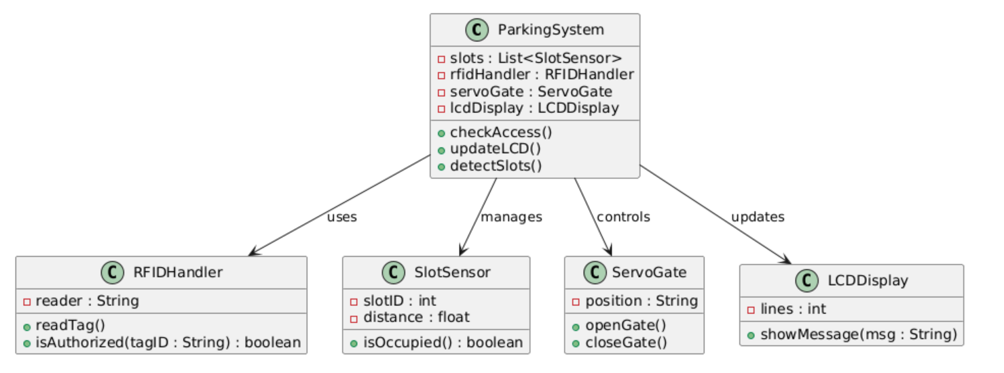
Figure 1:Class Diagram
Description
The class diagram visually represents the system's logical structure, showing classes, attributes, methods, and their relationships.

Purpose
To illustrate how different modules like RFID, sensors, gate control, and display interact within the Smart Parking System.

Sequence Diagram

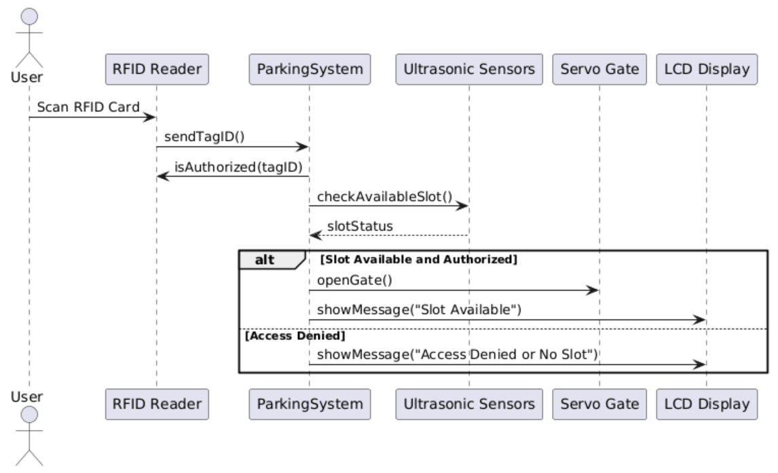
Figure 2:Sequence Diagram

Description
A sequence diagram shows the order of interactions between system components over time.

Purpose
To visualize the step-by-step flow of operations from RFID scanning to gate opening and parking slot update.

State Transition Diagram
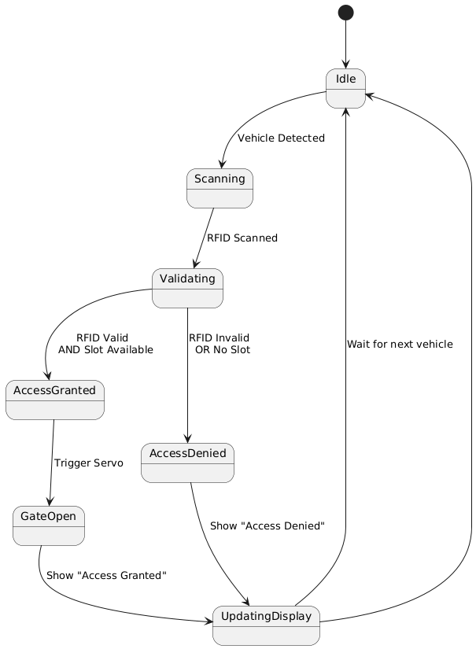
Figure 3:State Transition Diagram
Description
A state transition diagram shows how a system moves between different states based on events or conditions.

Purpose
To illustrate the various operating states of the parking system, such as idle, scanning, validating, granting access, or denying entry.

Entity-Relationship Diagram (ERD)

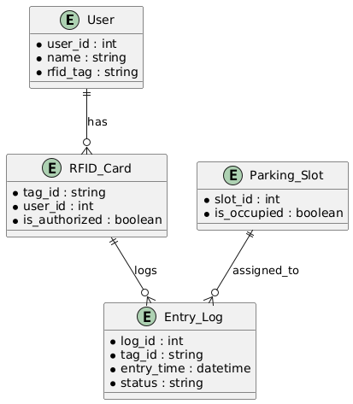
Figure 4:ERD Diagram
Description
An ERD (Entity Relationship Diagram) shows the relationships between different data entities in a system.

Purpose
To visualize how core data entities like users, RFID cards, and parking slots are related in the Smart Parking System.

Data Flow Diagram (DFD)

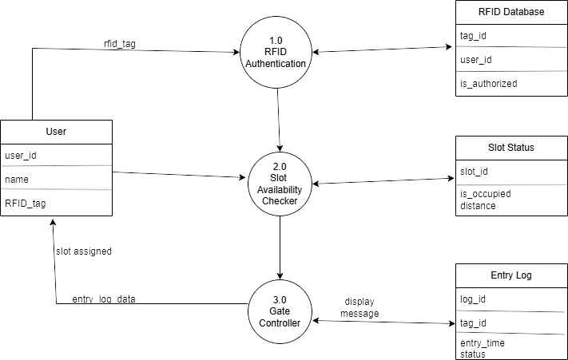
Figure 5:DFD Diagram

Description
A Data Flow Diagram (DFD) visually represents how data moves through the smart parking system, from user authentication to slot assignment and gate control.
Purpose
The purpose of the DFD is to illustrate the system's functional flow and how different components exchange information, helping in understanding and designing the system architecture.

Architectural Design

Introduction
The architectural design outlines the structural layout of the system, showing how different components interact to achieve system goals such as user authentication, slot management, and gate control using RFID technology.[8]

Architecture Style
We adopt a Three-Tier Architecture, which separates the system into three main layers:

Presentation Layer
User interface interactions (e.g., mobile/web app display).

Business Logic Layer
Handles core operations like RFID authentication and slot checking.

Data Access Layer
Manages storage and retrieval from the database (e.g., slot status, user logs).

Process Flow

RFID Scanning
A vehicle user approaches the parking entrance and scans their RFID tag at the scanner.
The RFID Reader reads the tag ID and sends it to the controller system.

Authentication Process
The tag ID is checked in the RFID Database.
If the user is authorized, the process proceeds. If not, access is denied, and a message is displayed.

Slot Availability Check
The system queries ultrasonic sensors or slot status records to find the nearest unoccupied slot.
The slot data includes slot_id, is_occupied, and optionally distance.

Slot Assignment & Gate Control
The system assigns a slot to the user and updates the slot status as "occupied".

The Gate Controller is triggered to open, allowing vehicle entry.

Entry Logging
Entry details (RFID tag, time, slot) are logged into the Entry Log database.

User Notification
A confirmation message is displayed to the user, including assigned slot information.

Methodology
The Waterfall Model is a linear sequential software development methodology. In this model, each phase must be completed before the next one begins, and there’s no overlapping in the phases.

Phases of the Waterfall Model

Requirement Analysis
Activities:
  - Gather functional and non-functional requirements.
  - Identify system users: vehicle users, admin, gate controller.
  - Define system behavior (e.g., how RFID authentication works, how to assign slots).
Deliverables: Requirement Specification Document.

System Design
Activities:
  - Create DFD (Data Flow Diagram).
  - Design system architecture: including modules like RFID Authentication, Slot Checker, Gate Controller, and Entry Logger.
  - Define database structure: User Table, RFID DB, Entry Logs, Slot Status.
Deliverables: Design Documents (Architectural diagram, ER diagram, DFD).

Implementation
Activities:
    - Java/XML for Android App.
    - Firebase for database handling.
    - Arduino/C for hardware interfacing (RFID, Ultrasonic Sensor, Servo Motor).
Deliverables: Functional source code of the system.

Integration & Testing
Activities:
  - Combine hardware (RFID reader, gate motor) with software (mobile app, database).
  - Test each part: RFID recognition, slot check logic, gate control, data logging.
  - Use unit and system testing techniques.
Deliverables: Fully tested integrated system.

Deployment
Activities:
  - Deploy the system on-site (or simulated environment).
  - Connect app to Firebase and hardware to a power source.
Deliverables: Operational Smart Parking System.

Maintenance
Activities:
  - Bug fixing and future enhancements.
  - Maintain Firebase database and clean old records.
Deliverables: Updated system with improvements (as needed).

Justification
Reason | Description
Clear Project Scope | The scope and system functionalities (e.g., RFID scan, slot detection, gate control) were clearly defined from the beginning.
Stable Requirements | There were no frequent changes in user or system requirements, which aligns well with Waterfall’s rigid structure.
Simple and Understandable | As a student project, Waterfall is ideal due to its step-by-step process, making planning and documentation easier.
Good for Hardware Integration | Since hardware components (RFID, sensors, motors) were fixed early, a linear model works well for combining hardware + software in a controlled flow.
Ideal for Academic Timeline | The project has a defined deadline, so Waterfall helps stick to a clear schedule without unexpected iterations.
Documentation-Driven | Academic projects often require thorough documentation at every phase—Waterfall naturally supports that.
Table 6:Justification

CHAPTER NO.5

TESTING

Testing
Software testing is the process of evaluating a software application or system to identify:
- Defects or bugs,
- Ensure functionality,
- Verify that the software meets the specified requirements.
It helps to ensure:
- The software behaves as expected,
- It is reliable, secure, and performs well under different conditions.

Purpose of Testing:
- Validate the correctness of software.
- Ensure the app meets user expectations.
- Find and fix issues before deployment.
- Improve quality and user satisfaction.

Black Box Testing

Definition
Tests the system without knowledge of internal code or logic. You test only the input/output behavior of the software.[9]

Characteristics
- Focuses on functionality, not internal structure.
- Test cases are based on requirements.
- Performed by testers or end users.

Techniques
- Equivalence partitioning
- Boundary value analysis
- Decision table testing

In our Project
- RFID scanning: Does it allow valid users and reject invalid ones?
- Slot checking: Is the user shown a correct available slot?
- Gate control: Does the gate open when a valid card is scanned?
- Mobile app interface: Does the login/signup work? Does it show correct status?
- Firebase data logging: Are entries recorded accurately?

How to Perform
- Test inputs: Valid and invalid RFID cards.
- Expected output: Correct gate behavior, proper messages, accurate logging.
- Observe behavior: Did the app/gate perform the expected action?

White Box Testing

Definition
Tests the internal structure and code logic of the application.

Characteristics
- Also called glass box or structural testing.
- Performed by developers.
- Involves reviewing code, logic paths, conditions, and loops.

Techniques
- Statement coverage
- Branch coverage
- Path testing
- Loop testing

In our Project:
- Testing logic in Java methods (e.g., validating email and password in SignupActivity).
- Verifying slot assignment logic.
- Checking Firebase data write/read operations.
- Debugging the Arduino code for RFID and gate control.

How to Perform

Analyze code paths
E.g., in RFID reader logic: What happens if card is invalid? What if sensor fails?

Check conditionals
For example: if (slotAvailable && isRFIDValid) { openGate(); }

Unit test functions
  - Android Studio testing tools (JUnit).
  - Arduino Serial Monitor (for hardware code).

Test Cases
A test case is a set of conditions or actions used to verify a particular feature or function of a software system.[10]
It includes:
- Test Case ID
- Test Scenario
- Test Steps
- Expected Result
- Actual Result
- Status (Pass/Fail)
Test cases help ensure requirements are met, and the application works as intended under different conditions.

Field | Description
Test Case ID | TC001
Test Scenario | User with a valid RFID tag tries to enter the parking area
Test Steps | 1. Present valid RFID tag 2. System checks RFID 3. Gate controller opens 4. Slot is assigned
Input Data | RFID: A1B2C3D4
Expected Result | Display: “Welcome. Slot 12 assigned. Gate opened.” Entry logged in database
Actual Result | (Example) Same as expected
Status | Pass
Table 7:Test-Case-1

Field | Description
Test Case ID | TC002
Test Scenario | Unregistered or unauthorized RFID card is used
Test Steps | 1. Present invalid RFID tag 2. System checks RFID 3. Deny access
Input Data | RFID: Z9X8Y7W6
Expected Result | Display: “Access Denied. Unauthorized tag.” Gate remains closed
Actual Result | Same
Status | Pass
Table 8:Test-Case-2

Field | Description
Test Case ID | TC003
Test Scenario | Code correctly selects the nearest unoccupied slot
Test Steps | 1. Simulate 3 slots: S1 (occupied), S2 (free, distance 10m), S3 (free, distance 5m) 2. Run checkNearestSlot() function 3. Verify assigned slot
Input Data | Slots = [{S1: occupied}, {S2: free, 10m}, {S3: free, 5m}]
Expected Result | Slot S3 should be assigned
Actual Result | Slot S3 assigned
Status | Pass
Table 9:Test-Case-3

CHAPTER NO.6

GRAPHICAL USER INTERFACE

Introduction
A Graphical User Interface (GUI) is the visual layer of an application that enables users to interact with the system using elements like buttons, forms, icons, and menus. In your project, the GUI allows users (e.g., parking staff, system admins, or even vehicle owners) to interact with the RFID-based parking system efficiently.[11]

Purpose of GUI
- Provide user-friendly access to the parking system.
- Display real-time data like slot availability, authentication status, and entry logs.
- Allow administrators to monitor, update, or manage system components (RFID data, slots).
- Help users receive feedback through display messages (like gate open, slot assigned, access denied).

GUI Components to Include
You should mention and explain each screen/page included in your GUI. Here are the recommended components:

Login Screen (Admin or Operator)
- Fields: Username, Password
- Purpose: Secure access to system dashboard

RFID Tag Reader Screen
- Live display of tag being scanned
- Result: Display authentication status ("Authorized" / "Access Denied")

Slot Availability Dashboard
- Graphical view of all parking slots
- Slot status: Color-coded (e.g., green = available, red = occupied)
- Optional: Show distances for each slot

Gate Controller Status Display
- Shows if gate is Open / Closed
- Shows which user is entering, slot number, and timestamp

Entry Log Viewer
- Table: tag_id, entry_time, status
- Search or filter by date/user

Slot Management Panel
- Admin view to update or override slot statuses manually

RFID Database Manager
  - Add new RFID tags
  - Remove/update user authorization

Human Interface Design
The Human Interface Design (HID) defines how users interact with the system’s software and hardware components. In our RFID-based Smart Parking System, the HID ensures a seamless, intuitive, and error-free interaction between users (like parking staff or vehicle owners) and the system (RFID reader, slot status, gate controller).[12]

Key Components of the Interface

RFID Tag Reader Interface
- Allows users to authenticate their identity quickly via RFID card scanning.

Slot Availability Display
- Shows free and occupied slots in real-time (visual indicator via LED, LCD, or mobile app).

Gate Controller Interface
- Automatically opens the gate for authorized users.
- Provides entry confirmation message or denial reason.
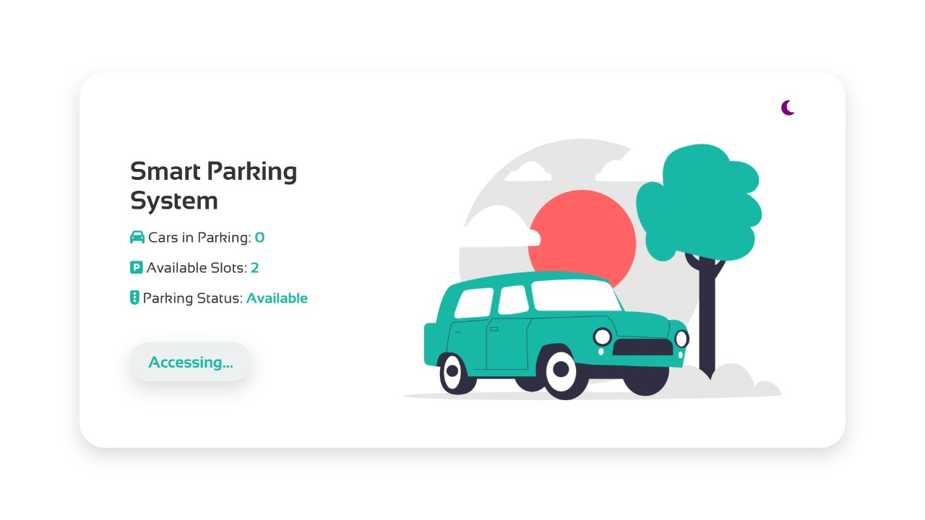
Figure 6:Web Page View

CHAPTER NO.7

CONCLUSION

Introduction
The conclusion chapter provides a summary of the project, reflecting on the objectives achieved, the outcomes produced, and the learnings gathered throughout the development process. It also outlines potential improvements and possible future enhancements to ensure the project remains scalable, efficient, and relevant.

Conclusion of Project
The RFID-Based Smart Parking System has successfully addressed the key challenges associated with traditional parking management, such as unauthorized access, manual entry logging, and inefficient space usage. Through RFID authentication, real-time slot checking, and automated gate control, the system ensures secure, fast, and automated vehicle entry[13].
The integration of ultrasonic sensors, microcontrollers (like NodeMCU/Arduino), and the Blynk mobile application has allowed for seamless hardware-software interaction and a user-friendly interface. The use of Waterfall model methodology provided a clear, structured approach that facilitated systematic development, testing, and deployment.
By implementing this system, we have minimized human error, reduced the need for manual monitoring, and significantly improved parking space utilization and security.

Future of the Project

Mobile Payment Integration
Adding digital wallet or UPI-based payments for parking fees directly through the app.

License Plate Recognition (LPR)
Combining RFID with camera-based LPR for dual-layer security.

Cloud-Based Storage
Storing logs and analytics in the cloud for remote administration and long-term data analysis.

Multiple Entry/Exit Points Support
Scaling the system to manage large multi-level parking areas or smart cities.

Dynamic Slot Reservation
Letting users reserve slots in advance via the Blynk app or web interface.

Energy Optimization
Using solar power for operating sensors and controllers to promote green technology.

CHAPTER NO. 8

REFERENCES

1. Kumar, R., & Kaur, P. (2017). RFID Based Smart Car Parking System. International Journal of Applied Engineering Research, 12(17), 6559–6563. Retrieved from https://www.ripublication.com/ijaer17/ijaerv12n17_35.pdfRIPublication

2. Encstore. (2023). RFID-Based Parking Management System and How It Works. Retrieved from https://www.encstore.com/blog/5572-rfid-based-parking-management-system-and-how-it-works

3. Sharma, A., & Verma, R. (2021). RFID Based Smart Parking System. International Research Journal of Engineering and Technology, 8(3), 543–546. Retrieved from https://www.irjet.net/archives/V8/i5/IRJET-V8I5115.pdfIRJET
4. Fresh USA. (n.d.). RFID Parking Management Systems. Retrieved from https://www.fresh222.com/rfid-solutions/parking-systems/

5. Chawla, M. (2020). Car Parking Security System with RFID Technology and Web Portal with Database. Medium. Retrieved from https://medium.com/@chawlamahima76/car-parking-security-system-with-rfid-technology-and-web-portal-with-database-a55b6352b0

6. Electronics For You. (2016). RFID Based Automatic Vehicle Parking System. Retrieved from https://www.electronicsforu.com/electronics-projects/hardware-diy/rfid-based-automatic-vehicle-parking-system

7. Wei, L. X., & Wu, Q. S. (2012). Design and Implementation of Smart Parking Management System Based on RFID and Internet. ResearchGate. Retrieved from https://www.researchgate.net/publication/261526624_Design_and_Implementation_of_Smart_Parking_Management_System_Based_on_RFID_and_Internet
8. Nevon Projects. (n.d.). IOT Smart Parking Using RFID With Android App. Retrieved from https://nevonprojects.com/iot-smart-parking-using-rfid-with-android-app/Nevon Projects
9. International Journal for Research in Applied Science and Engineering Technology. (2024). IOT Based Smart Parking System Using RFID. Retrieved from https://www.irjmets.com/uploadedfiles/paper//issue_10_october_2024/62288/final/fin_irjmets1728965080.pdfIRJMETS

10. Instructables. (2023). Arduino and RFID Based Smart Parking System. Retrieved from https://www.instructables.com/Arduino-and-RFID-Based-Smart-Parking-System/Instructables

11. International Journal of Engineering Research & Technology. (2022). RFID Based Smart Parking System. Retrieved from https://www.ijert.org/research/rfid-based-smart-parking-system-IJERTV11IS070127.pdfIJERT

12. Wayleadr. (2021). RFID Parking Systems and Alternative Options. Retrieved from https://wayleadr.com/blog/a-look-at-rfid-parking-systems-and-alternative-options/Wayleadr\

13. RFID Label. (2023). The Ultimate Guide to RFID in Smart Traffic Management and Parking Solutions. Retrieved from https://www.rfidlabel.com/the-ultimate-guide-to-rfid-in-smart-traffic-management-and-parking-solutions/

